**ENSF-381**: **Full Stack Web Development Laboratory**

**Lab03**

**Section: 2**

**Group information:**

Name 1 (UCID#)

Arnav Arya

30211140

Name 2 (UCID#)

Liam Mercier

30185192

**GitHub Link:**

<https://github.com/LittleMercyEh/ENSF381LAB3/tree/main>

**Exercise 1 Output:**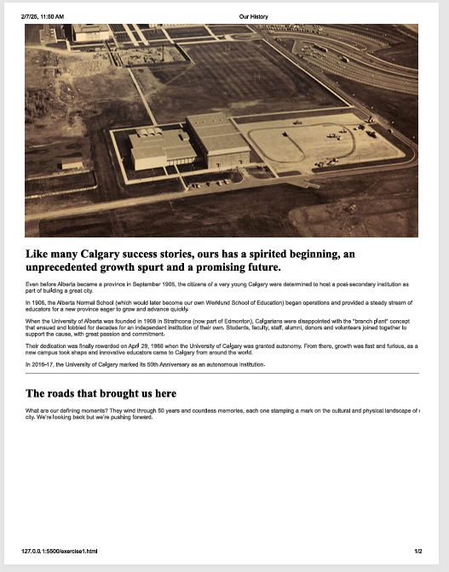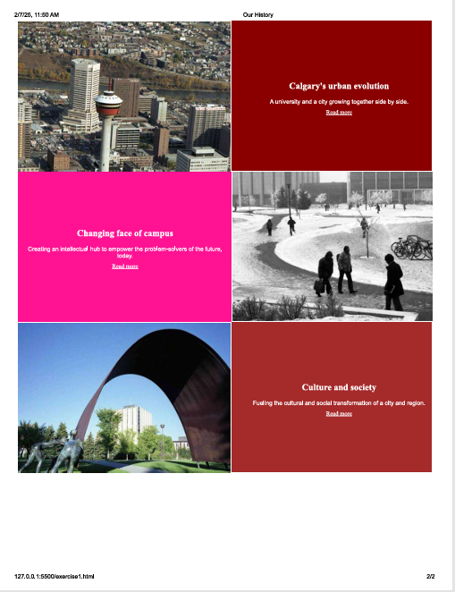

**Exercise 2 Output:**

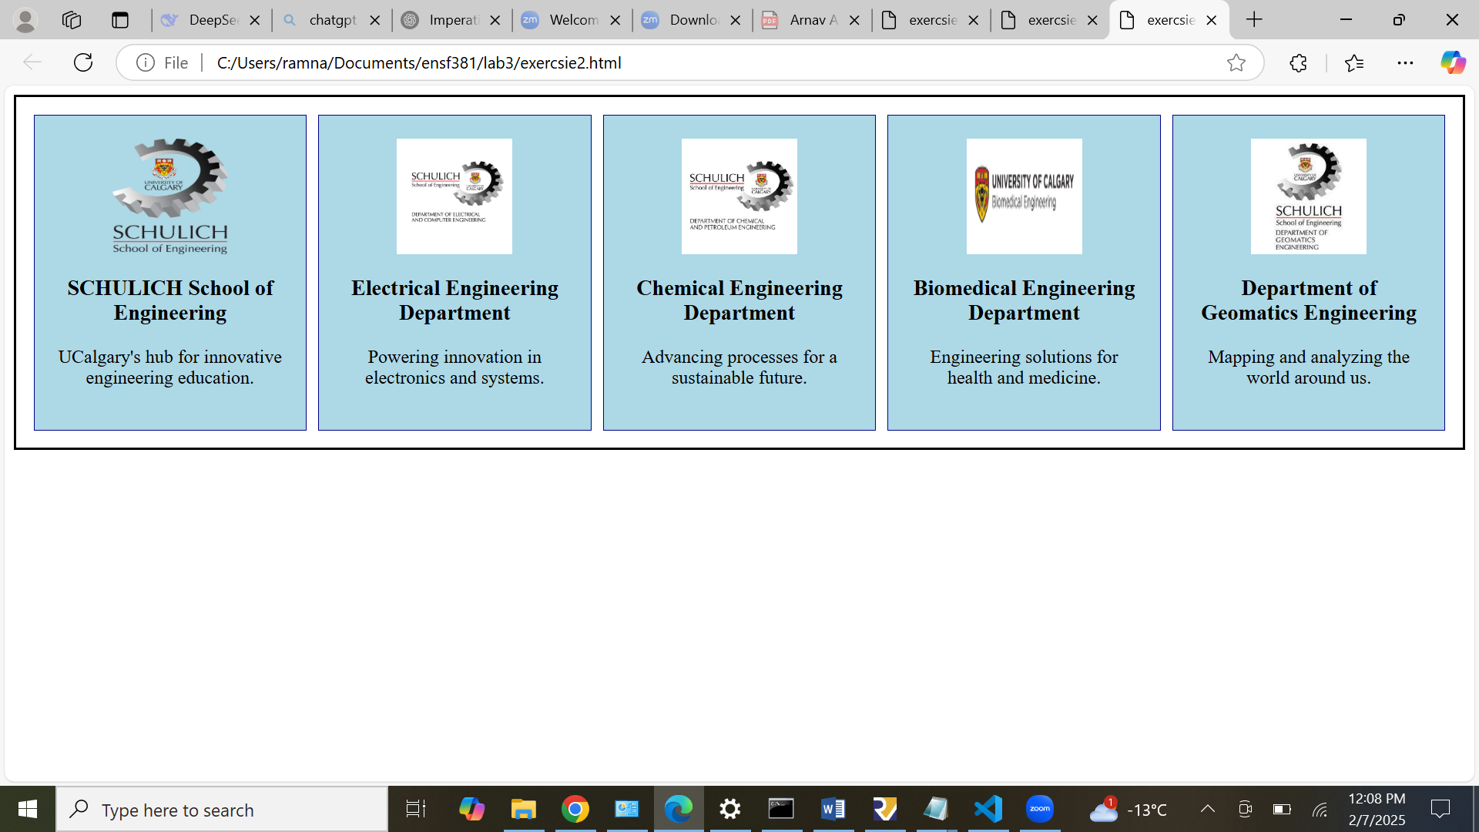

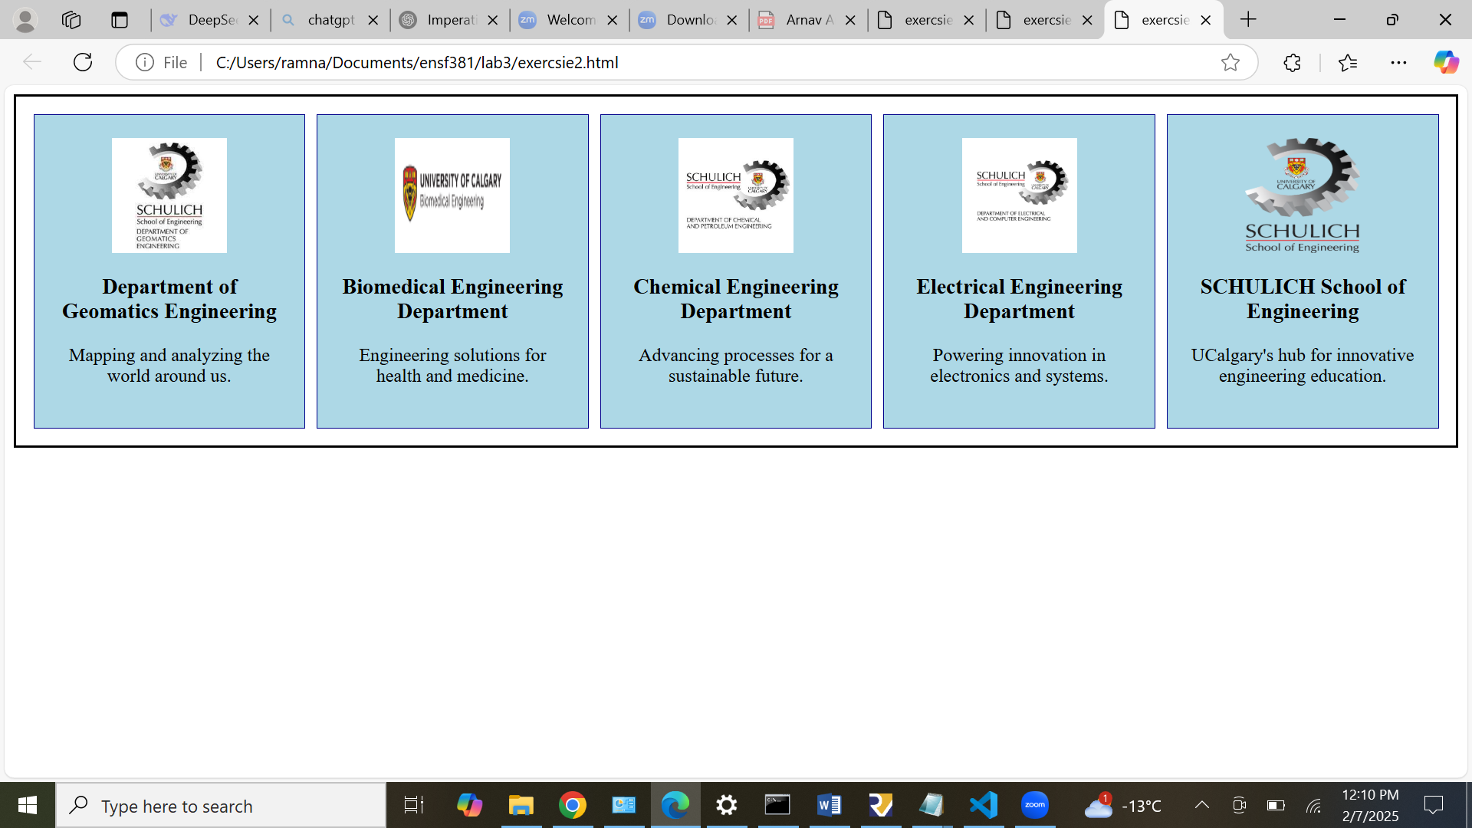

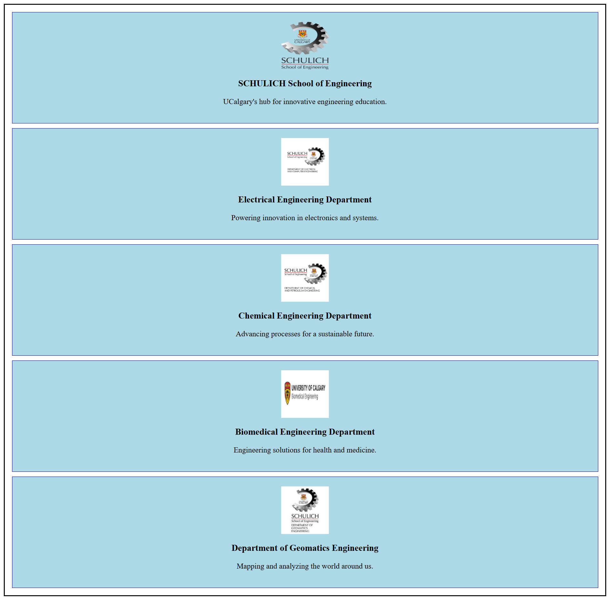

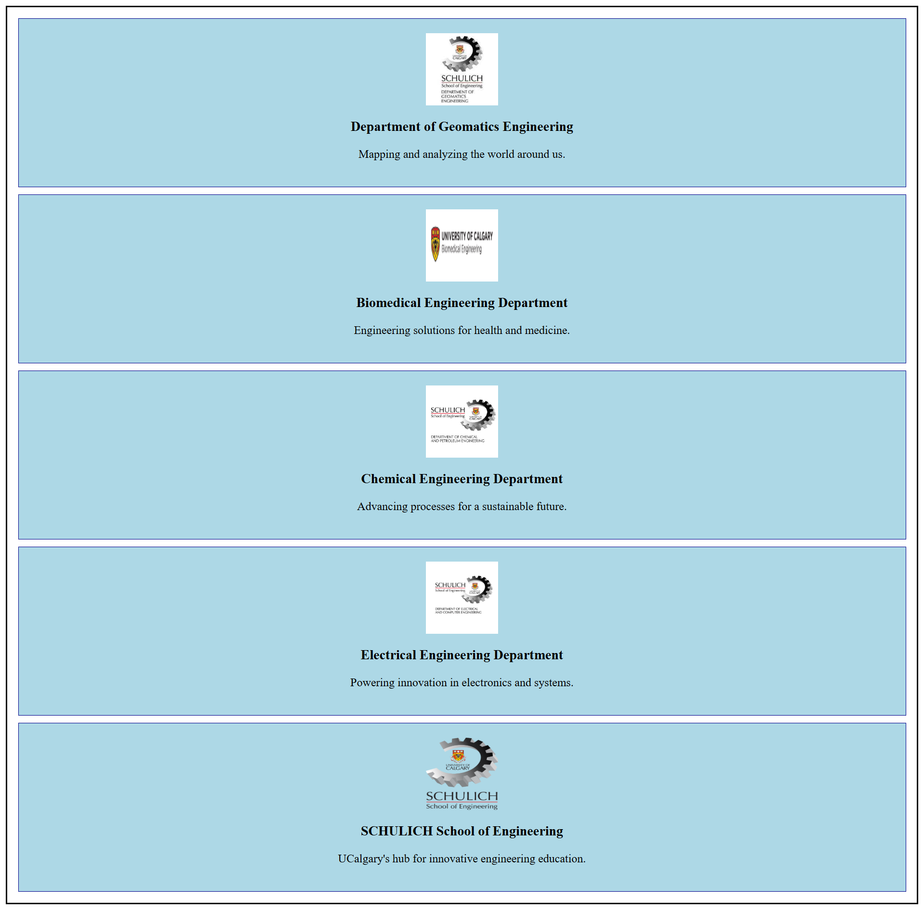

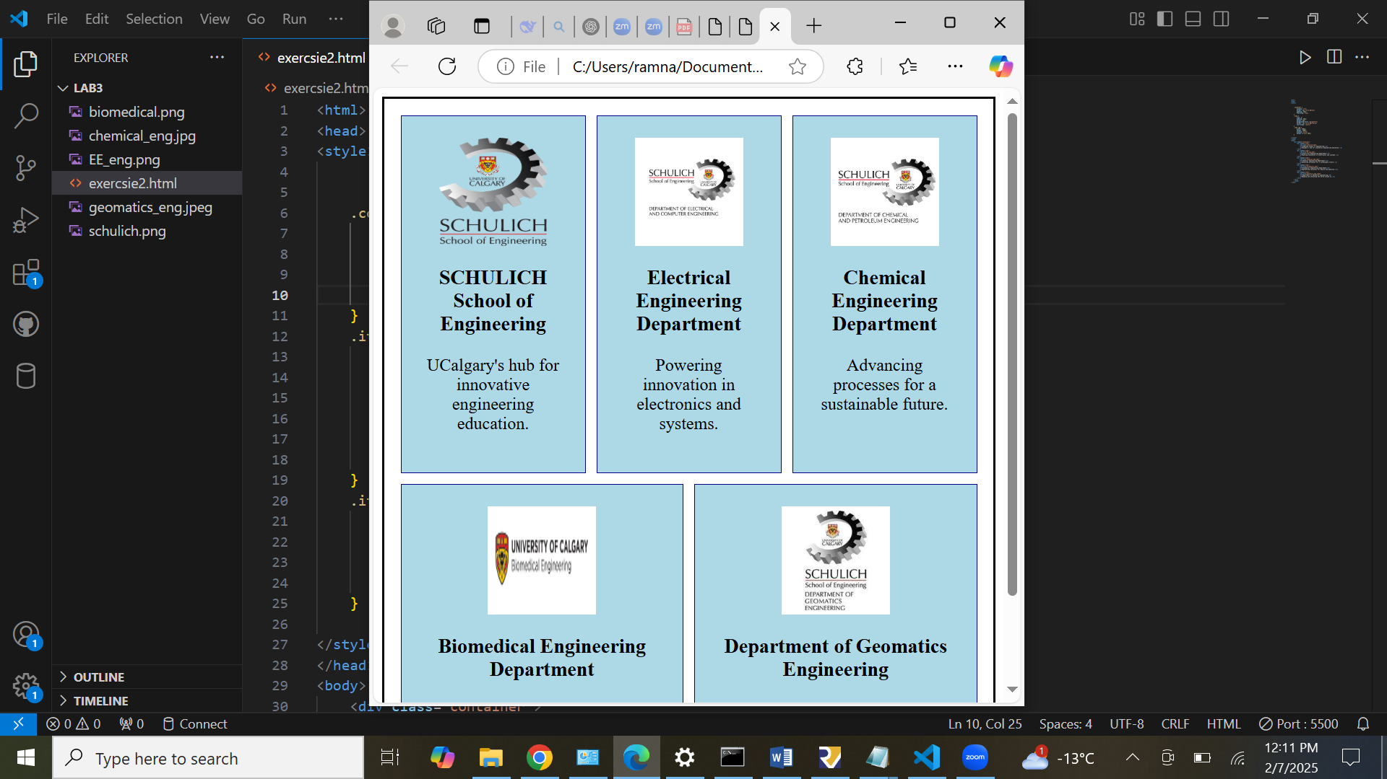

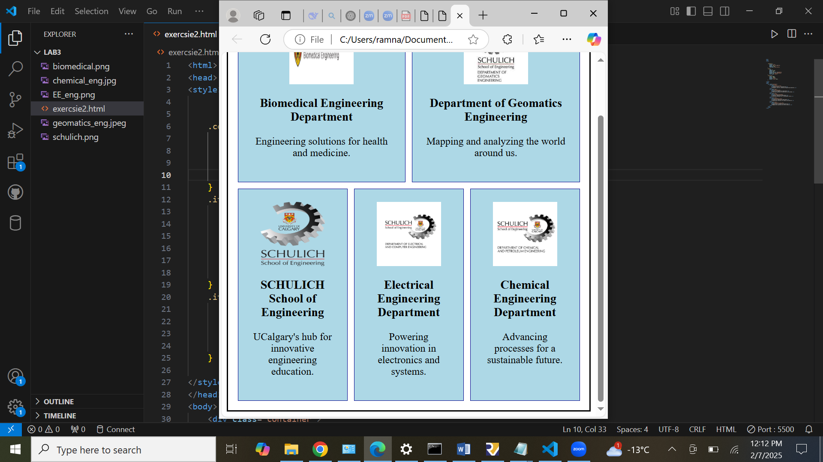

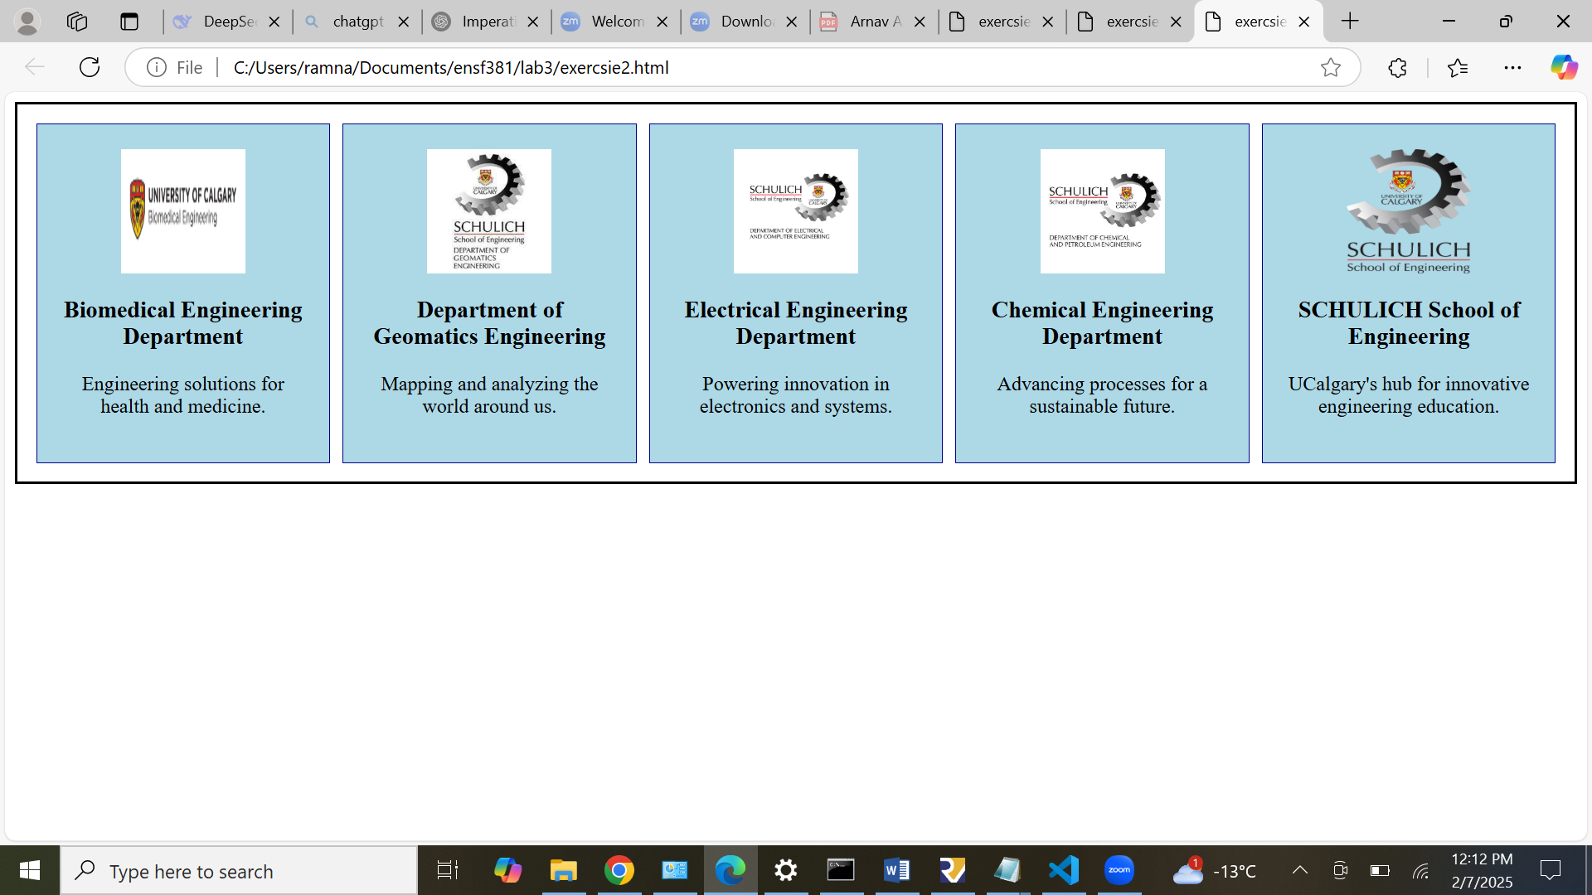

**Exercise 3 Output:**

